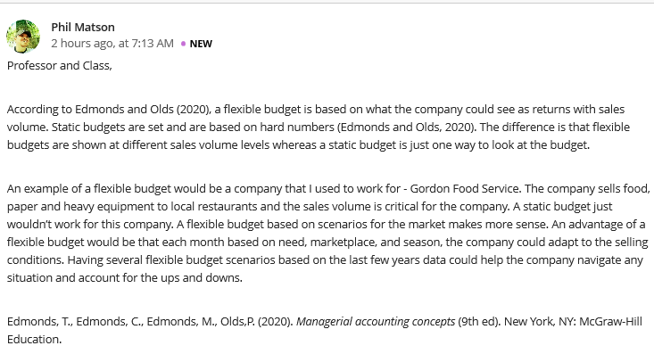
Student 1
Hi Matson
Even though the two types of budgeting play a significant role in the budgeting of scarce resources, flexible budget remains to be the most outstanding type of budgeting that one can imagine. It gives room for divergent views; it reflects the expenditure appropriate to various levels of output. Most of the expenditures that are established through a flexible budget are suitable for comparison mainly of the actual expenditure incurred with the budgeted level applicable majorly for that particular level of activity attained. Thus making it be the most preferred.
Furthermore, this type of budgeting has proved to have the ability to reckon the operational realities and streamlines control function and profit planning. We can therefore agree that given a market scenario, the company using a flexible budgeting approach can adapt so much easily than the one that focuses much on the static option.

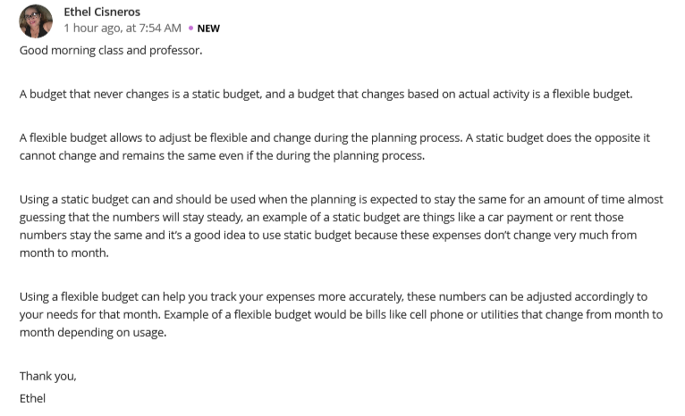
Student 2
Hello Cisneros
Aligning an organization’s budget to ever changing activities in the market can be of a great importance to the general progress of an organization as much as proper planning is concerned. Applying static budget can a times create a challenge based on the fact that it’s very difficult to factor in Inflation and all other unforeseen disasters when planning because no one can ascertain when and how far it can hit the economy at large.
It’s absolutely correct to state that most of activities like paying rent might not change every month, but we can still realize that for the case of an enterprise that does its yearly budgeting, approach might create unnecessary inconveniences that will later require for the planning team to go back into the drawing board and be able to alter the budget a little bit.

